# Circuit guidelines

*Rules always have exceptions... You may be allowed to disregard design rules if you can explain why doing so would improve your design. Consult Albert or Kalman before doing so.*

## CAD software

* **Only Autodesk Eagle files will be accepted**. Eagle is free for students to use, sign up with your DTU mail.
* Use the Design Rules found in the Resources folder.
* Use the CAM processor found in the Resources folder to process the Gerber files.

## Remarks

* If designing a circuit with a microcontroller or CAN interface, please use the microcontroller and CAN template.
* CAN connectors sho0uld be 2 pin JST-XHs, with CAN_LOW on p and CAN_HIGH on pin 2.

## Components

* All components must be through-hole, with the exception of coils
* All LED indicators should be 5mm through hole LED’s.
* All resistors must be E12 0.5W / 0.33W
* All semiconductors or IC’s must be DIP, TO-92 or TO-220, all with a pin spacing of 2.54mm
* (All microcontrollers should be ATMEGA 328P-PU)
* (All CAN chips should be MCP’s)
* Power ON state must be shown by LED

## Connectors

* **The first pin of the connector is always ground (if present)**
* **The second pin of the connector is always power (if present)**
* JST-XH (angled): for low voltage and signal applications
* JST-VL: for low voltage high current (3+ A) applications
* TE Connectivity MATE-N-LOK (angled): for high voltage applications
* Pin headers (2.54mm): for programming and for interconnecting stacked PCBs

## Workflow

* **All designs must be simulated and tested on a breadboard before a PCB will be ordered.**
* All PCBs must be proven to work on a through-hole PCB before any SMD-based PCB will be considered.
* All tests must be documented to enable repeatability.

# Layout

## Dimensions

* Always use a ground plane - except for HV application
* All mounting holes should be M3 (4 mm diameter)
* The distance between mounting holes should always be a power of 2 times 45, eg. the spacing must follow the formula: $2^{n}×45\text{mm}$
* The distance from the center of a mounting hole to the edge should be at least 5mm
* The smallest possible PCB is a 55x55mm board. All boards with hole distance larger than 45mm should have 6 holes to allow for smaller boards to be mounted on top.
* Example:

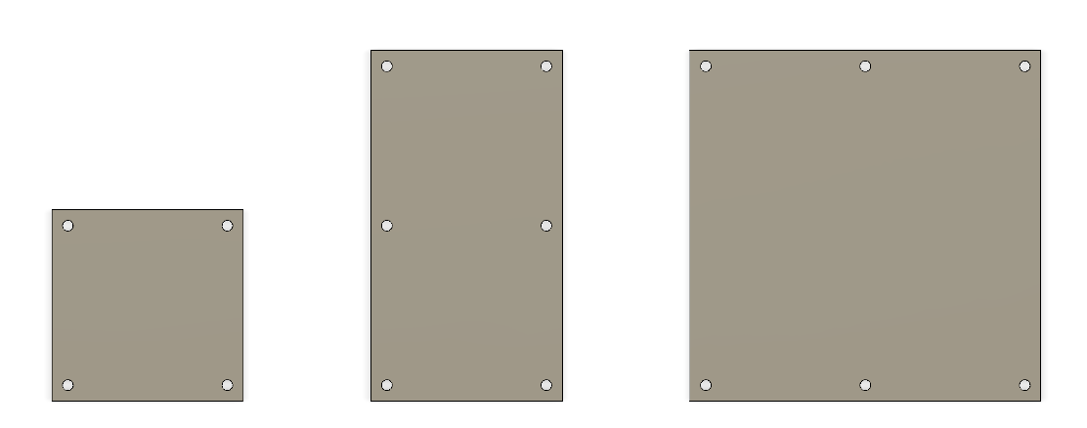

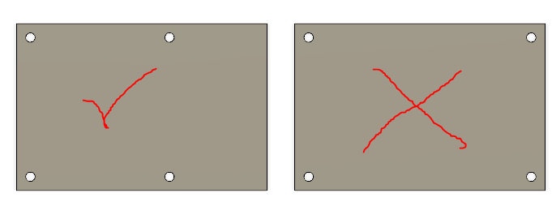

## Connector placement

* All JST-XH connectors should be angled connectors
* Always use connectors with as many pins as possible when signals leave the board for the same subsystem. Eg. use a 4 pin connector instead of 2x 2 pin connectors if they go the same place.
* Power supply and CAN connectors should always be placed all the way to the right
* All JST-XH connectors should be placed on a single edge of the PCB (where possible)
* JST-XH Connectors should always be placed on the longest edge of the PCB (where possible)
* All input connections should be towards the left side of the PCB (where possible)
* All output connections should be towards the right side of the PCB (where possible)
* Example:

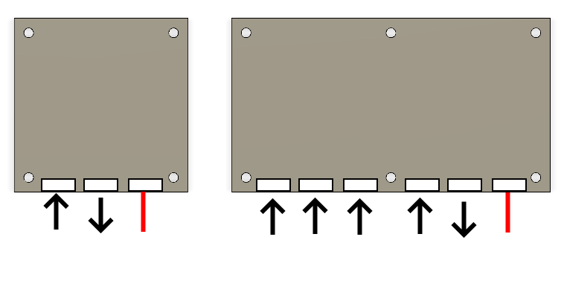

# PCB Checklist

|  |  |
| --- | --- |
| Only through-hole components used? |  |
| Component requirements fulfilled? |  |
| Only specified connectors used? |  |
| Dimension requirements fulfilled? |  |
| Connectors placed correctly? |  |
| Circuit checked verified by co-student? |  |
|  |  |

# Notes for assembly

* All DIP’s should use a DIP-socket.
* Cut excess legs after soldering components
* Double-check all IC orientations
* Check board with a multimeter before powering up for the first time